Spinal Cord Injury and Traumatic Brain Injury Research Grant Program:

January 15, 2018

Report

Authors
Alaina DeSalvo
Competitive Grants Administrator
Tel: 651-259-3988
Alaina.DeSalvo@state.mn.us

About the Minnesota Office of Higher Education
The Minnesota Office of Higher Education is a cabinet-level state agency providing students with financial aid programs and information to help them gain access to postsecondary education. The agency also serves as the state’s clearinghouse for data, research and analysis on postsecondary enrollment, financial aid, finance and trends.
The Minnesota State Grant Program is the largest financial aid program administered by the Office of Higher Education, awarding up to $180 million in need-based grants to Minnesota residents attending accredited institutions in Minnesota. The agency oversees tuition reciprocity programs, a student loan program, Minnesota’s 529 College Savings Plan, licensing and early college awareness programs for youth.

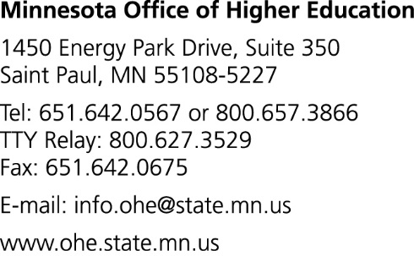



Table of Contents

Table of Contents 3
Introduction 4
Spinal Cord Injury and Traumatic Brain Injury Advisory Council……………………………………………….………………………5
FY 2018 Proposal Solicitation Schedule and Proposals Received 7
Annual Research Grant Selection Process 9
2018 Spinal Cord Injury and Traumatic Brain Injury Research Projects…………………………………………………….…….10
2018 Timeline and Anticipated Outcomes……….…………………………………………………………………………………………….13
Appendix A: Copy of Statute………………………………………………………………………………………………………………………….15
Appendix B: MN Spinal Cord and Traumatic Brain Injury Research Symposium Flyer and Agenda………………….18
Appendix C: Fiscal Year 2016/2017 Progress Summaries……………………………………………………………………………….22
Appendix D: Copy of Fiscal Year 2018 Annual Research Grant Request for Proposals…………………………………….26
Appendix E: Annual Research Grant Proposal Review Form…………………………………………………………………………..54

Introduction
The State of Minnesota established the Spinal Cord Injury and Traumatic Brain Injury (SCI-TBI) Research Grant Program effective July 1, 2015. Minnesota 2015 Session Law, Chapter 69 directed the Commissioner of the Minnesota Office of Higher Education to establish a grant program for institutions in Minnesota to conduct research that would lead to new and innovative treatments and rehabilitative efforts for the functional improvement of people with spinal cord injuries and traumatic brain injuries. Research areas include, but are not limited to, pharmaceutical, medical device, brain stimulus and rehabilitative approaches and techniques. Appendix A provides a copy of the grant program’s funding statute.
For the 2018-2019 biennium, $3,000,000 was made available each year from the 2017 Omnibus Higher Education Bill to support the SCI-TBI Grant Program. As directed by the program’s statue, the Commissioner of the Office of Higher Education, in consultation with the program’s advisory council, will allocate 50 percent of the grant funds to research involving spinal cord injuries and 50 percent to research involving traumatic brain injuries throughout the biennium.
Due to the timing of the legislative session and the annual SCI-TBI grant cycle, fiscal year (FY) 2018 funds were separated into two grant cycles: the Annual Research Grant Program and the Supplemental Funding Grant. The Commissioner of the Office of Higher Education, in consultation with the Spinal Cord and Traumatic Brain Injury Advisory Council, awarded a total of $1,512,858 in June 2018 to support the Annual Research Grant Program. Twelve new research projects received support-- eight spinal cord injury research projects and four traumatic brain injury research projects.

Supplemental Funding Grant
The purpose of the Supplemental Funding Grant is to support projects that have already received initial funding from the State of Minnesota through the Spinal Cord Injury and the Traumatic Brain Injury Research Grant. The funds are intended to expand and enhance these projects so that they can have a greater impact in the area of spinal cord and traumatic brain injury research.
The Minnesota Office of Higher Education will grant awards of up to $100,000 to Traumatic Brain Injury Research grantees and $50,000 to Spinal Cord Injury Research grantees using a competitive grant-making process. Proposals will be chosen based on progress made on the project thus far (relative to the grantees’ approved project timeline), rationale for additional funding, and appropriateness of budget/budget justification. Preference will be given to grantees who have leveraged outside funding for their project.
Fiscal year 2016, 2017, and 2018 Spinal Cord Injury and Traumatic Brain Injury Research grantees are eligible to apply for supplemental funding. In February 2018, the Spinal Cord and Traumatic Brain Injury Advisory Council will make recommendations to the Commissioner by evaluating the proposals received, based on the following criteria:
- Current state of research: Applicants are asked to describe how their research started and the current status of their research.
- Successes: Applicants are asked to describe their markers of success, and what successes they are able to cite thus far in their research. This may include, but is not limited to: 1) IRB/IACUC, FDA, or other regulatory clearance; 2) recruitment or initiation of work with subjects; and/or 3) experiments performed
- Data/Results: Applicants are asked to describe the data they have collected and the results they have examined at this stage in their research. This may include, but is not limited to: 1) poster presentations and/or 2) abstracts written.
- Dissemination of Research: Applicants are asked how results to date have been innovative and/or undergone peer review. This may include, but is not limited to: 1) patents; 2) papers; and/or 3) other grants, such as with the National Institute of Health.
- Use of Funds: Applicants are asked how the supplemental funding will be used to enhance their current project.
- Budget and Budget Justification: Applicants must show and justify how the money will be spent to enhance their current project.
The timeline for the Supplemental Funding Grant Solicitation is as follows:
November 17, 2017 All potential applicants are notified of funding opportunity
4:30 p.m., January 10, 2018 Deadline for receipt of proposals
February 12, 2018 Council reviews proposals and makes recommendations
February 22, 2018 Notification of recommendation for grant award
March 1, 2018 - June 30, 2018 Project funding interval (amendments to current contracts)

Spinal Cord Injury and Traumatic Brain Injury Advisory Council
The 2015 statute language establishing the grant program also established the Spinal Cord and Traumatic Brain Injury Advisory Council. The Commissioner, in consultation with the Advisory Council, has the responsibility of awarding the SCI-TBI grants, and developing the program. In 2015, an initial 12-member Advisory Council was set up using the Open Appointments process of the Minnesota Secretary of State’s office. Dr. Walter Low, Professor, Associate Head for Research and Director of the Research Laboratories in the Department of Neurosurgery at the University of Minnesota, served as the Advisory Council chair. In 2017, the statute language was updated to include two new positions: 1) a veteran with a traumatic brain injury, and 2) a physician specializing in the treatment of spinal cord injury. Several of the 2015 appointments were also up for renewal. Again, the Commissioner of the Office of Higher Education selected the 14-member council through the Open Appointments process. The full membership of the Advisory Council is shown below; new members are bolded:

Member | Representing
Dr. Uzma Samadani (chair) | Physician specializing the in treatment of traumatic brain injury
Dr. Walter Low | University of Minnesota Medical School
Dr. Peter Grahn | Mayo Clinic
Dr. Mary Radomski | Courage Kenny Rehabilitation Center
Dr. Sarah Rockswold | Hennepin County Medical Center
Dr. Ann Parr | Neurosurgeon
Mr. Robert Wudlick | Person with a spinal cord injury
Mr. Matthew Rodreick | Family member of a person with a spinal cord injury
Ms. Kristina Nozal | Person with a traumatic brain injury
Mr. Stephen Thell | Veteran who has a spinal cord injury
Mr. Joseph Oppold | Veteran who has a traumatic brain injury
Dr. Mark Gormley | Gillette Children’s Specialty Healthcare
Ms. Susan McGuigan | Family member of a person who has a traumatic brain injury
Dr. Steven Jackson | Physician specializing in the treatment of spinal cord injury
The Commissioner of the Office of Higher Education selected Dr. Uzma Samadani to supercede Dr. Walter Low as the chair of the Spinal Cord and Traumatic Brain Injury Advisory Council.

Spinal Cord Injury and Traumatic Brain Injury Research Symposium
The Advisory Council, along with additional stakeholders of spinal cord research and traumatic brain injury research, are planning a research symposium to highlight contributions made to the field due to the Spinal Cord Injury and Traumatic Brain Injury Research Grant Program. The symposium is scheduled for January 31, 2018 and will feature researchers, patients, nonprofit organizations, community members, and more – all gathering together to share progress and disseminate research. The symposium is not funded through the State of Minnesota; Advisory Council members solicited donations from hospitals, businesses, and non-profits in order to host this gathering. See Appendix B for more information on the symposium, including a promotional flyer and agenda.

FY 2018 Proposal Solicitation Schedule and Proposals Received

Fiscal Year 2018 Annual Research Grant Proposal Solicitation Schedule
To support research projects with FY 2018 program funding, the following timeline was used to solicit proposals and award grant funds:
March 1, 2017 Request for Proposals available to applicants
May 8, 2017 Deadline for receipt of intent to submit forms
4:30 p.m., May 19, 2017 Deadline for receipt of proposals
June 15, 2017 Notification of recommendation for grant award
July 1, 2017 - June 30, 2018 Project funding interval
A copy of the Fiscal Year 2018 Request for Proposals for the Minnesota Spinal Cord Injury and Traumatic Brain Injury Research Grant Program is provided in Appendix D.
Fiscal Year 2018 Annual Research Grant Proposals Received
The Spinal Cord and Traumatic Brain Injury Advisory Council received a total of 15 proposals: nine focusing on spinal cord injury research and six focusing on traumatic brain injury research. A combined total of $1,796,675 was requested.

Spinal Cord Injury Research | Amount Requested
Project Title: Safety and Feasibility of Low Level Epidural Electrical Stimulation for Individuals with SCI  Principal Investigator: Dr. Kristin Zhao  Institutional Affiliation: Mayo Clinic | $128,750
Project Title: Modulating the Spinal Cord Microenvironment and Sublesional Circuitry using Epidural Stimulation with Electrically Conductive Hydrogel Scaffolds Seeded with Schwann Cells  Principal Investigator: Dr. Igor Lavrov  Institutional Affiliation: Mayo Clinic | $128,750
Project Title: Metabolic Risk Factors as Targets to Improve Rehabilitation Outcomes after Spinal Cord Injury  Principal Investigator: Dr. Isobel Scarisbrick  Institutional Affiliation: Mayo Clinic | $128,750
Project Title: Optimizing Epidural Spinal Cord Stimulation to Restore Cardiovascular Function after Spinal Cord Injury  Principal Investigator: Dr. David Darrow  Institutional Affiliation: Minneapolis Medical Research Foundation | $128,750
Project Title: Enhancing Recruitment for a Bladder Neurostimulation Trial after Acute Spinal Cord Injury  Principal Investigator: Dr. Sean Elliot  Institutional Affiliation: University of Minnesota Medical Center | $41,316
Project Title: Upper Body Dynamic Positioning System for Persons with SCI  Principal Investigator: Dr. Gary Goldish  Institutional Affiliation: Minnesota Veterans Medical Research and Education Foundation | $128,750
Project Title: Precision Placement of Spinal Neural Progenitor Cells in Patient-Specific 3D Bio-Printed Scaffolds for Chronic Spinal Cord Injury Repair  Principal Investigator: Dr. Ann Parr  Institutional Affiliation: Regents of the University of Minnesota | $128,749
Project Title: Accelerating the Differentiation of Human Pluripotent Stem Cells to Treat Spinal Cord Injury  Principal Investigator: Dr. James R. Dutton  Institutional Affiliation: Regents of the University of Minnesota | $128,750
Project Title: Development of a Powered Hand Grip System for Quadriplegia  Principal Investigator: John Zentgraf  Institutional Affiliation: AbiliTech Medical, Inc. | $128,750
TOTAL AMOUNT REQUESTED | $1,071,315
Traumatic Brain Injury Research | Amount Requested
Project Title: Effectiveness of a Neck-Strengthening Program for the Prevention or Mitigation of Sports Concussion Injuries in Student Athletes  Principal Investigator: Dr. Thomas Bergman  Institutional Affiliation: Minneapolis Medical Research Foundation | $121,250
Project Title: Therapeutic Application of Non-Hematopoietic Umbilical Cord Blood Stem Cells (nh­UCBSCs) in Traumatic Brain Injury: Immune Modulation with Acute and Long Term Benefits  Principal Investigator: Dr. Andrew W. Grande  Institutional Affiliation: Regents of the University of Minnesota | $121,250
Project Title: Eyetracking and Neurovision Rehabilitation of Oculomotor Dysfunction in Mild Traumatic Brain Injury (mTBI)  Principal Investigator: Dr. Sarah Rockswold  Institutional Affiliation: Minneapolis Medical Research Foundation | $121,250
Project Title: Auditory and Vestibular Effects in Traumatic Brain Injury  Principal Investigator: Dr. Sebahattin Cureoglu  Institutional Affiliation: Regents of the University of Minnesota | $121,250
Project Title: Web-based Vocational Intervention for Individuals with TBI  Principal Investigator: Dr. John Ferguson  Institutional Affiliation: Minneapolis VA Health Care System | $121,250
Project Title: Exploring the Role of Combined Cognitive and Motor Dual-Task Assessment and Rehabilitation for Individuals with Residual Symptoms After mTBI  Principal Investigator: Dr. Margaret Weightman  Institutional Affiliation: Allina Health | $119,109
TOTAL AMOUNT REQUESTED | $725,359

Annual Research Grant Selection Process
At the June 12, 2017 meeting, the Advisory Council members completed their reviews of the 15 submitted research proposals and recommended 12 proposals for funding as FY 2018 Annual Research Grants.
To complete this task, review panels of Advisory Council members were established for each specialty area (traumatic brain injury and spinal cord injury). Each proposal was reviewed and scored by members of the specialty area review panel reflective of the proposal’s research focus. For the review, Advisory Council members with a scientific background gave particular attention to the scientific and technical merit of the proposals, while members with patient or community perspectives gave particular attention to the importance of the proposed research for patients. Proposals were scored individually and discussed during the June meeting. Advisory Council members were required to disclose any conflict of interest with any submitted proposals. If conflict of interest was present, the Advisory Council member did not review the proposal and was excluded from the room when the proposal was discussed.

2018 Spinal Cord Injury and Traumatic Brain Injury Research Projects
Pursuant to the language of the statute establishing the research grant program, members of the Spinal Cord and Traumatic Brain Injury Advisory Council reviewed research proposals and recommended proposals for funding to the Commissioner. The Proposal Review Form used by the Advisory Council members is found in Appendix E. The 12 fiscal year 2018 projects recommended and funded were:

2018 Spinal Cord Injury Research Grant Project Summaries
Safety and Feasibility of Low Level Epidural Electrical Stimulation for Individuals with SCI, Mayo Clinic, receives $128,750
Motor function in patients after spinal cord injury (SCI) can be improved by electrical epidural stimulation (EES), as this study recently confirmed in replicating the study of work previously conducted at the University of Louisville. Through this study, investigators seek to assess the safety and impact of long-duration, low-intensity EES on quality of life, autonomic functions, and volitional motor ability in subjects previously implanted with an EES system. The researchers hypothesize that EES applied at low (below eEmc) voltage intensities will improve overall quality of life factors when compared to no stimulation during activities of daily living. They further hypothesize that low-intensity, long-duration stimulation will not inhibit volitional motor functionality enabled by EES. Results from this work will have a high impact on subsequent clinical trials by providing information on the safety of low-intensity EES during extended durations, while reporting any changes in quality of life, autonomic function, and control of volitional function enabled via EES.
Principal Investigator: Dr. Kristin Zhao, 507-284-8942, zhao.kristin@mayo.edu
Modulating the Spinal Cord Microenvironment and Sublesional Circuitry Using Epidural Stimulation with Electrically Conductive Hydrogel Scaffolds Seeded with Schwann Cells,
Mayo Clinic, receives $128,750
In this project, researchers propose to regenerate neural tissue through the lesion site, as well as enhance signals that travel through by stimulating either across or distal to the lesion in combination with locomotor training. For this, they will combine EES with an electrically-conductive hydrogel scaffold seeded with SCs to enhance regeneration into the site of a complete thoracic spinal cord transection in rodents. They hypothesize that modulating spinal circuitry through and below the injury using EES will facilitate functional and anatomical reconnection through the scaffold and improve neurologic function. Results from this research will have a high impact on application of spinal cord neuromodulation strategies.
Principal Investigator: Dr. Igor Lavrov, 310-980-4457, lavrov.igor@mayo.edu

Metabolic Risk Factors as Targets to Improve Rehabilitation Outcomes after Spinal Cord Injury, Mayo Clinic, receives $128,750
The researcher’s hypothesis is that features of systemic metabolic dysfunction, including insulin resistance and a pro­inflammatory state, are mirrored in the adult spinal cord where they exacerbate injury, impede spontaneous recovery, and limit responses to rehabilitation. The researchers further hypothesize that a well-studied insulin sensitizing agent, Metformin, can be administered to overcome these effects and metabolically condition the spinal cord to improve responses to treadmill training in the acute and more chronic periods after SCI. This study will investigate 1) whether administration of an insulin sensitizer can improve spontaneous recovery, 2) whether outcomes in mice that develop metabolic dysfunction more chronically after SCI can also benefit from metabolic conditioning applied alone or in the context of treadmill training, and 3) the relevance of findings to individuals with SCI by determining the impact of metabolic risk factors on recover of Functional Independence Measures. This project will advance a new paradigm of metabolic targeting to enhance outcomes and the efficacy of rehabilitation after SCI.
Principal Investigator: Dr. Isobel A. Scarisbrick, 507-284-0124, scarisbrick.isobe1@mayo.edu
Optimizing Epidural Spinal Cord Stimulation to Restore Cardiovascular Function after Spinal Cord Injury, Minneapolis Medical Research Foundation receives $128,750
This research project addresses what epidural spinal cord stimulation settings should be used from the millions of possibilities to improve the blood pressure and cardiac output of SCI patients with dysautonomia, and what are the longer term consequences of therapy on the cardiovascular system. Additionally, researchers will investigate the effects of epidural stimulation on cardiovascular structure and function by using a novel trial design and home-based platform to allow patients to continue to live their normal lives while participating in research to improve their lives and the lives of those who may benefit from eSCS in the future. This study will have a direct impact on the treatment and rehabilitation of patients with SCI, as the development of therapies for autonomic dysfunction manifesting as blood pressure variability may save lives.
Principal Investigator: Dr. David Darrow, (214) 564-0623, darro015@umn.edu
Upper Body Dynamic Positioning System for Persons with SCI, Minnesota Veterans Medical Research and Education Foundation, receives $128,750
The goal of this study is to improve the range of motion of those with limited movement or no control of their torso or "trunk" by collaborating change. This study will bring together a Minnesota-based team to work directly with Minnesota residents with SCI and develop a trunk control system that will dynamically assist with upper body positioning, improve bimanual workspace, provide pressure relief on the ischial tuberosities and sacrum, and shift the center of mass forward, which will improve stability during inclined wheelchair propulsion. This research grant will provide a critical next step in researchers’ efforts to develop cutting edge trunk control solutions, leading to greater independence and functional improvement for persons with SCI.
Principal Investigator: Dr. Gary Goldish, 612-467-3538, gary.goldish@va.gov
Precision Placement of Spinal Neural Progenitor Cells in Patient-Specific 3D Bio-Printed Scaffolds for Chronic Spinal Cord Injury Repair, Regents of the University of Minnesota, receives $128,749
The purpose of this research project is to combine expertise in clinical grade stem cell differentiation and custom three-dimensional (3D) bio-printing to precisely position human spinal neural progenitors within a 3D scaffold which is shaped to fit individual patient lesions, in order to optimize repair of the injured spinal cord. The hypothesis is that transplantation of human induced pluripotent stem cells (iPSC)-derived ventral spinal neural progenitor cells (VSNPCs) printed into a tailored 3D bio-printed scaffold will result in improved functional recovery after chronic contusion spinal cord injury. To date, no group has successfully printed neuronal progenitor cells and growth factors directly into a patient-specific 3D scaffold, and this work will introduce new technology for treating complex SCI.
Principal Investigator: Dr. Ann M. Parr, 612-624-6666 amparr@umn.edu
Accelerating the Differentiation of Human Pluripotent Stem Cells to Treat Spinal Cord Injury, Regents of the University of Minnesota, receives $128,750
Researchers would like to better understand dorsoventral patterning for production of specific interneuron and motor neuron subtypes of the spinal cord. This study hypothesizes modulation of specific factors within a specific time frame will allow for appropriate and precise patterning of this tissue to allow for production of various neural progenitors of the spinal cord. Researchers will then assess engraftment potential of these neural progenitors in­vivo to mimic their use in a clinical setting. Researchers currently have a new, accelerated method for producing neurectoderm from undifferentiated hiPSCs in a defined, clinically relevant manner. Building upon this method to produce various neurons of the spinal cord would extend the usefulness of new technology, creating additional new discoveries.
Principal Investigator: Dr. James R. Dutton, 612-626-2762, dutto015@umn.edu
Development of a Powered Hand Grip System for Quadriplegia, AbiliTech Medical Inc., receives $128,750
The purpose of this project is to develop and demonstrate the feasibility of the Hand Grip system to enable individuals with cervical SCI to perform activities of daily living (ADLs) and user controlled repetitive movements for ambulatory rehab. Development of this device is focused on designing a low-cost, portable, and highly functional hand grip system. Innovative elements are the use of optimized power sourcing, stand-alone models, body activated finger movement and the ability to integrate the hand grip system with an upper extremity exoskeleton that has a platform for connecting to a clinical tracking software application. The Hand Grip system will help individuals with cervical SCI perform ADLs and improve access to hand rehabilitation. This system also has potential to help people living with other disease conditions such as Traumatic Brain Injury, Stroke, ALS, CP, MD, and more.
Principal Investigator: John Zentgraf, 651-260-6673, jzentgraf@me.com
2018 Traumatic Brain Injury Research Grant Project Summaries
Effectiveness of a Neck-Strengthening Program for the Prevention or Mitigation of Sports Concussion Injuries in Student Athletes, Minneapolis Medical Research Foundation, receives $121,250
The core hypothesis of this research is that increased neck strength reduces the incidence of concussion and severity of clinical outcomes. Their general working hypotheses are that: (1) regular participation in targeted manual-resistance exercises is effective for strengthening the necks of student athletes aged 14 to 22; and (2) youth with greater overall baseline and post­training neck strengths are less likely to experience concussion and have better recovery of post-concussion symptoms. In this single-arm, multicenter, observational, open analytical study, the researchers will partner with six member schools of the Independent Metro Athletic Conference and Gustavus Adolphus College and measure neck strength in 1500 male and female athletes and administer traditional and novel cognitive assessments. They will then implement a neck-strengthening regiment into subjects’ regular training schedule and assess the impact of neck-strengthening among participants over the course of six months. The study could have an impact on youth concussion risk, as it targets significant and under-studied risk factors for traumatic brain injury in children and adolescents.
Principal Investigator: Dr. Thomas Bergman, 612-873-2810, thomas.bergman@hcmed.org
Therapeutic Application of Non-Hematopoietic Umbilical Cord Blood Stem Cells (nh­UCBSCs) in Traumatic Brain Injury: Immune Modulation with Acute and Long Term Benefits, Regents of the University of Minnesota, receives $121,250
The intent of this innovative study is twofold. First, assess whether non-hematopoietic umbilical cord blood stem cells, given intravenously after TBI, is effective to reduce the inflammatory response following TBI, leading to decrease tissue injury and improved outcomes. Secondly, determine if neuroinflammation can be imaged with MRI using the Delta Relaxation Enhance MR sequence. According to the researchers, there are limited therapies to inhibit this inflammatory response after TBI. But, in the few studies focused on reducing this inflammation, there has been associated decreased areas of tissue injury and improved outcome.
Current treatment of TBI is aimed at preventing secondary complication. The novel cellular therapy which this research will use has already been shown to do this in stroke where similar neuroinflammatory processes exist. If successful, this cellular therapy research would be a paradigm shift in the management of TBI. The long-term impacts are potentially endless.
Principal Investigator: Dr. Andrew W. Grande, 612-624-6666, grande@umn.edu
Eyetracking and Neurovision Rehabilitation of Oculomotor Dysfunction in Mild Traumatic Brain Injury (mTBI), Minneapolis Medical Research Foundation, receives $121,250
Mild TBI is a significant cause of disability, especially when symptoms become chronic. In HCMC’s experience, this chronicity is often linked to oculomotor dysfunction (OMD). The core of this research is to assess how a visual stimulus and eye tracking system can predict the presence or absence of TBI related OMD as diagnosed by a developmental optometrist (OD). To that end, Mild TBI patients who exhibit OMD based on eye tracking system, will respond positively to neuro vision rehabilitation (NVR) confirmed by objective measurements on OD examination. Currently, there is a lack of an efficient, user friendly, diagnostic test available for OMD to allow primary care physicians to identify mTBI patients appropriate for referral to OD or for NVR. The impact of this research on treatment and rehab efforts for functional improvement of people with TBI is in under 4 minutes, the eye tracker will objectively identify patients who may have TBI related OMD.
Principal Investigator: Dr. Sarah Rockswold, 612-873-2810, sarah.rockswold@hcmed.org
Exploring the Role of Combined Cognitive and Motor Dual-Task Assessment and Rehabilitation for Individuals with Residual Symptoms After mTBI, Allina Health, receives $119,109
The goal of this project is twofold: intervention and assessment. Intervention: a protocol for progressive rehabilitation intervention using a combined cognitive and motor dual-task approach to assist with resolution of persistent symptoms after mTBI. Accordingly, the overarching hypothesis is that a combined motor and cognitive rehabilitation will be more beneficial than a single domain approach for treating persistent symptoms of mTBI. Assessment: expands upon prior research on dual-task assessments by further evaluating and refining dual task measures including the use of wearable inertial sensors to improve objective measures for determining readiness to return to full activity after mTBI. Findings from this line of research will pave the way for more effective rehabilitation after mTBI and will provide rehabilitation professionals more objective information for determination for safe return to full activity, sport, or military duty.
Principal Investigator: Dr. Margaret M. Weightman, 612-863-6525, margaret.weightman@allina.com

2018 Timeline and Anticipated Outcomes
The project directors for FY 2018 research projects have a time period of July 1, 2017 (or the grant execution date) through June 30, 2018 for conducting their project. If additional time is needed they will be offered a
no-cost one-year extension, extending the contract end date to June 30, 2019. It is anticipated that most, if not all, projects will require the additional year to complete. Supplemental Funding Grant awards will supplement these projects and projects from past cycles in order to expand and enhance existing work and make significant contributions to the field.
Advisory Council members anticipate that through the innovations cited in the recommended research projects, and collaboration with other nationally-reknowned researchers, the novel outcomes from the funded projects should lead to advances in the fields of spinal cord injury and traumatic brain injury.

APPENDIX A: COPY OF STATUTE

LAWS OF MINNESOTA 2017

136A.901 SPINAL CORD INJURY AND TRAUMATIC BRAIN INJURY RESEARCH GRANT PROGRAM.

Subdivision 1.Grant program.
The commissioner shall establish a grant program to award grants to institutions in Minnesota for research into spinal cord injuries and traumatic brain injuries. Grants shall be awarded to conduct research into new and innovative treatments and rehabilitative efforts for the functional improvement of people with spinal cord and traumatic brain injuries. Research topics may include, but are not limited to, pharmaceutical, medical device, brain stimulus, and rehabilitative approaches and techniques. The commissioner, in consultation with the advisory council established under section 136A.902, shall award 50 percent of the grant funds for research involving spinal cord injuries and 50 percent to research involving traumatic brain injuries. In addition to the amounts appropriated by law, the commissioner may accept additional funds from private and public sources. Amounts received from these sources are appropriated to the commissioner for the purposes of issuing grants under this section.

Subd. 2.Report.
By January 15, 2016, and each January 15 thereafter, the commissioner shall submit a report to the chairs and ranking minority members of the senate and house of representatives committees having jurisdiction over the Office of Higher Education, specifying the institutions receiving grants under this section and the purposes for which the grant funds were used.

Sec136A.902 SPINAL CORD AND TRAUMATIC BRAIN INJURY ADVISORY COUNCIL.

Subdivision 1.Membership.
The commissioner shall appoint a 14-member advisory council consisting of:
(1) one member representing the University of Minnesota Medical School;
(2) one member representing the Mayo Medical School;
(3) one member representing the Courage Kenny Rehabilitation Center;
(4) one member representing Hennepin County Medical Center;
(5) one member who is a neurosurgeon;
(6) one member who has a spinal cord injury;
(7) one member who is a family member of a person with a spinal cord injury;
(8) one member who has a traumatic brain injury;
(9) one member who is a veteran who has a spinal cord injury;
(10) one member who is a veteran who has a traumatic brain injury;
(11) one member who is a family member of a person with a traumatic brain injury;
(12) one member who is a physician specializing in the treatment of spinal cord injury;
(13) one member who is a physician specializing in the treatment of traumatic brain injury; and
(14) one member representing Gillette Children's Specialty Healthcare.

Subd. 2.Organization.
The advisory council shall be organized and administered under section 15.059, except that subdivision 2 shall not apply. Except as provided in subdivision 4, the commissioner shall appoint council members to two-year terms and appoint one member as chair. The advisory council does not expire.

Subd. 3.First appointments and first meeting.
The commissioner shall appoint the first members of the council by September 1, 2015. The chair shall convene the first meeting by November 1, 2015.

Subd. 4.Terms of initial council members.
The commissioner shall designate six of the initial council members to serve one-year terms and six to serve two-year terms.

Subd. 5.Conflict of interest.
Council members must disclose in a written statement any financial interest in any organization that the council recommends to receive a grant. The written statement must accompany the grant recommendations and must explain the nature of the conflict. The council is not subject to policies developed by the commissioner of administration under section 16B.98.
§

Subd. 6.Duties.
The advisory council shall:
(1) develop criteria for evaluating and awarding the research grants under section 136A.901;
(2) review research proposals and make recommendations by January 15 of each year to the commissioner for purposes of awarding grants under section 136A.901; and
(3) perform other duties as authorized by the commissioner.

APPENDIX B: MINNESOTA SPINAL CORD AND TRAUMATIC BRAIN INJURY RESEARCH SYMPOSIUM FLYER AND AGENDA

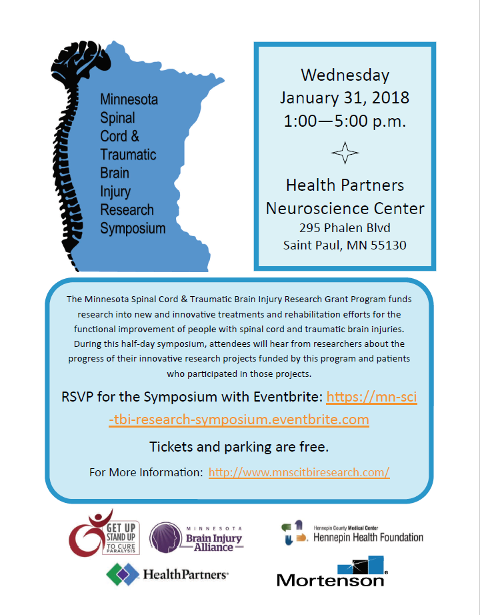
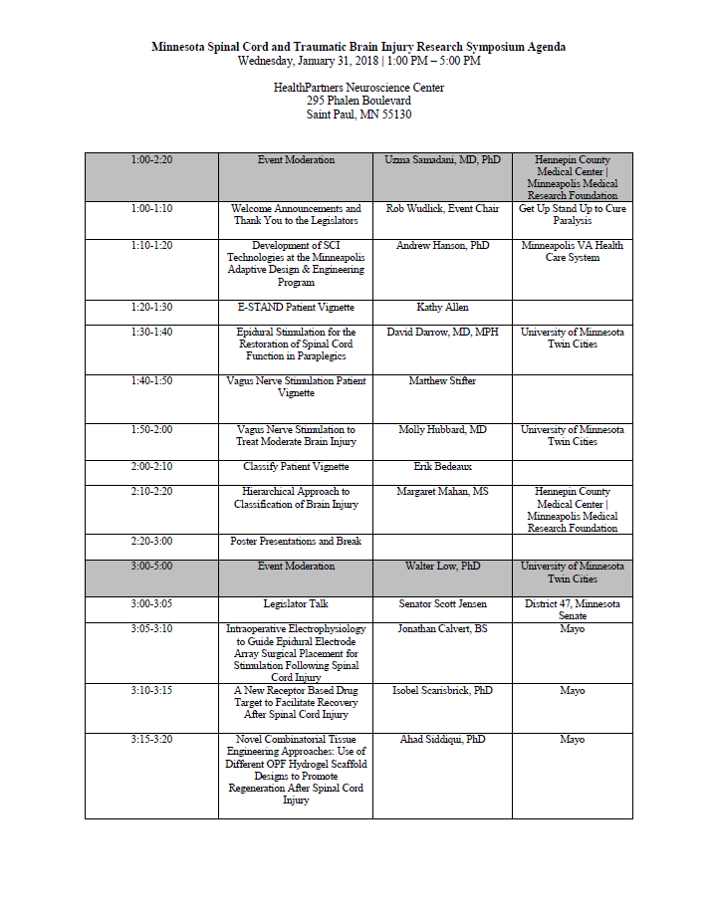
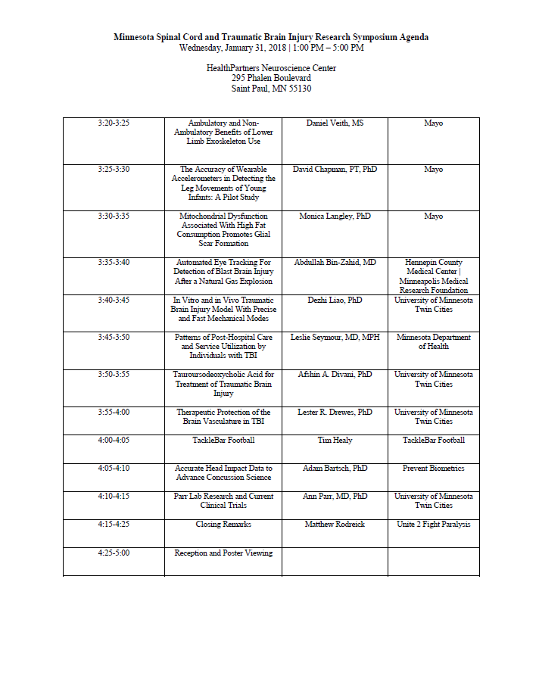

APPENDIX C: FISCAL YEAR 2016/2017 PROGRESS SUMMARIES

(As of February 2017)
FY 2016 / 2017 SCI-TBI Grantee Updates
Grant Year | Grantee | Project Title | Principal Investigator | Status | Successes to date
2016 | Hennepin County Medical Center | Traumatic Brain Injury Classification and Outcome Assessment | Dr. Chad Richardson | - Established a custom database management system that captures variety of patient information.  - Successfully screened over 1,300 patients and enrolled over 430 patients  - Using initial patients, Dr. Richardson has been assessing the standard of care in radiographic imaging while also investigating state of the art methods to establish effective protocol for MRI sequences to assess TBI. | - Active recruitment/enrollment  - Constructed unified data management platform that will provide a central location for data collection and allow them to integrate data from different measures to successfully achieve the goal of creating an objective, multimodal classification scheme and outcome assessment for TBI  - Successfully scanned almost 20 patients with MR sequence protocol
2016 | Hennepin County Medical Center/University of Minnesota | Epidural Stimulation for Spinal Cord Injury | Dr. David Darrow, Dr. Uzma Samadani | - 53 patients passed prescreening, 15 patients completed screening, 8 patients meet inclusion and exclusion criteria  - 4 patients demonstrated significant dysautonomic cardiovascular function by tilt table testing  - Recruitment and retention will be optimized through close follow-up and established during phase II of the study  - First device implantation surgery was scheduled for August 2017 | - The protocol of this project will be submitted to Clinical Trials for publication
2016 | University of Minnesota | Oligodendrocyte Progenitor Cells and Scar Ablation for the Treatment of Chronic Spinal Cord Injury | Dr. Ann M. Parr | - The utility of rose Bengal (FDA approved) for non-invasive glial scar photo ablation in a rat model of chronic spinal cord injury has been demonstrated  - Examined the effects Bengal derivatives (RB1, RB2, and RB3) on the glial scar of the chronically injured rat spinal cord in 4 distinct rat groups | - Significant findings due to experimentation
2016 | Hennepin County Medical Center | Neuroimaging and Neurovision Rehabilitation of Oculomotor Dysfunction in Mild Traumatic Brain Injury (mTBI) | Dr. Sarah B. Rockswold | - Obtained IRB approval for study Sept. 2016 (slower process than anticipated)  - Enrolled 10 subjects; two dropped out of study  - Visual testing, MRI scanning and neurovision rehabilitation have gone smoothly and without difficulty  - Currently attempting to increase recruitment (finding “ideal” subject for this study has been challenging)  - No adverse events | - None recorded
2017 | Minneapolis VA Health Care System/University of Minnesota | TDCS as an Intervention for Patients with Traumatic Brain Injury | Dr. Tasha Nienow | - Staff hired, equipment acquired and set up, recruitment methods established  - Staff trained to conduct screening and pre- and post- intervention assessments  - Participant recruitment began in month 4; approx. 50 individuals have been screened for eligibility  - Cognitive strategy training protocols and EEG assessment protocols developed  - Developed protocols and trained staff in tDCS administration procedures and offered enrollment to participants  - Recruitment and intervention activities will continue throughout the 2nd year | - Project is consistent with projected budget  - Recruitment has been slower than expected, and percentage of screened participants who are eligible is lower than anticipated (approx. 1 in 4)
2017 | University of Minnesota/Hennepin County Medical Center | Vagus Nerve Stimulation to Treat Mild to Moderate Traumatic Brain Injury | Dr. Molly Hubbard | - Enrolled additional 4 patients (total of 6) with 2 patients dropping out of study.  - Actively enrolling patients; Creating awareness of the study throughout the Twin Cities to increase enrollment  - No adverse side effects to date  - Two patients have finished the treatment period and have 1 remaining follow up prior to completing the study | - Active recruitment/enrollment  - No significant adverse events with the use of the device  - Subjects report satisfaction with using the devise and ease of fitting device into their lifestyles
2017 | Minneapolis Veterans Administration Health Care System | Enhancing Rehabilitation with Neuromodulation for Veterans with Spinal Cord Injury | Jeremiah J. Doyle | - External grant to provide research team with stimulator unit devices has been approved  - St. Jude Medical (Abbott) is finalizing contract with Minneapolis Veterans Medical Research to establish a materials transfer agreement  - IRB has been preliminarily approved pending revisions (submitted)  - Preparing a preliminary list of veterans who may qualify to participate in study  - Surgery clinic verified that use of clinic and/or space will be provided at no cost | - Outside support from Abbott in the form of donated devices  - MVAHCS SCI/D Center promises to be a secure collaboration with Hennepin County Medical Center and the University of Minnesota Department of Neurosurgery  - IRB will not need to go back to committee once revisions are approved.
2017 | Regents of the University of Minnesota | Muscle Powered Exoskeleton for Standing and Walking by People with Spinal Cord Injury | Dr. William K. Durfee | - Almost completed Aim 1 of the project (to design, fabricate and bench test the walking machine hardware)  - To date, the protoype has undergone several revisions  - Currently focused on body attachment points, including the use of a modular load-carrying backpack frame  - Next steps: refine the body attachment points and then run a complete set of quantitative bench tests (est. September 15, 2017). Remainder of project period will focus on Aim 2 (perform a small pilot study on 1-2 volunteers with SCI). | - Preliminary bench tests have indicated that the device will work to its intended purpose

APPENDIX D: COPY OF ANNUAL RESEARCH GRANT REQUEST FOR PROPOSALS

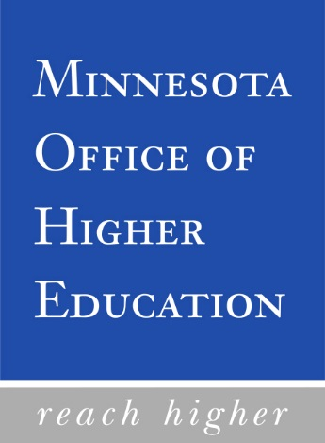
OFFICE OF HIGHER EDUCATON
1450 Energy Park Drive, Suite 350
St. Paul, MN 55108
651-642-0567 or 1-800-657-3866

REQUEST FOR PROPOSALS FOR THE MINNESOTA SPINAL
CORD INJURY AND TRAUMATIC BRAIN INJURY
RESEARCH GRANT PROGRAM

Laws of Minnesota 2015, Chapter 69, Article X, Section 13

DEADLINES

Intent to Submit Form – May 8, 2017
Grant Proposal – May 19, 2017

PROJECT PERIOD:

July 1, 2017 – June 30, 2018

Alternative Format:

Upon request, the Request for Proposals can be made available in an alternative format by contacting Nancy B. Walters, Ph.D., Office of Higher Education, 1450 Energy Park Drive, Suite 350, St. Paul, MN 55108, phone (651) 259-3907, fax (651) 642-0675. TTY users should contact the Minnesota Relay Service at 1-800-627-3529 and request assistance in contacting the Office of Higher Education.

REQUEST FOR PROPOSALS UNDER MINNESOTA 2015 SESSION LAW
SPINAL CORD INJURY AND TRAUMATIC BRAIN INJURY
RESEARCH GRANT PROGRAM

March 1, 2017
Minnesota Office of Higher Education

- OVERVIEW

The state of Minnesota established the Spinal Cord Injury and Traumatic Brain Injury Grant Program effective July 1, 2015. Minnesota 2015 Session Law, Chapter 69 directed the Commissioner of the Minnesota Office of Higher Education to establish a grant program for institutions in Minnesota for research into new and innovative treatments and rehabilitative efforts for the functional improvement of people with spinal cord and traumatic brain injuries. Research areas may include, but are not limited to, pharmaceutical, medical device, brain stimulus, and rehabilitative approaches and techniques.

Contingent upon 2017/2018 biennium funding, $500,000 will be available each year from the Omnibus Higher Education Bill to support the Spinal Cord Injury and Traumatic Brain Injury Grant Program. Three percent of this appropriation will be used for program administration. The Commissioner of the Office of Higher Education, in consultation with the program’s advisory council shall award 50 percent of the State grant funds for research involving spinal cord injuries and 50 percent to research involving traumatic brain injuries. In addition to the amounts appropriated by law, the commissioner may accept additional funds from private and public sources. To supplement Fiscal Year 2018 funding for the spinal cord injury research grants, a $15,000 donation was provided by the Get Up Stand Up to Cure Paralysis Foundation. See Appendix A for a description of the grant program and advisory council membership and duties.

The overall objective of this program is to foster and encourage innovative research for treatment and rehabilitative techniques for spinal cord and traumatic brain injuries. Funding support for research innovations may reflect an early investment as a researcher prepares to seek a larger grant award from a federal program or nonprofit organization. Therefore, preliminary data is not required but encouraged.

Because the nature and scope of the research proposed may vary, it is anticipated that the size of each award may vary, as well. Awards pursuant to this request are contingent upon the availability of funds and the receipt of meritorious proposals. As a small grant program, traumatic brain injury research proposals will be funded up to a maximum total request of $121,250 for the Fiscal Year 2018 grant period, which includes indirect costs set at 8% of total direct costs. The spinal cord injury research proposals will be funded up to a maximum total request of $128,750 for the Fiscal Year 2018 grant period, which includes indirect costs set at 8% of total direct costs.

- ELIGIBLE GRANT APPLICANTS

Eligible grant applicants must be lead institutions/organizations located within Minnesota and fall into one or more of the following categories: public/state controlled institution of higher education; private institution of higher education; nonprofit with 501(c)(3) IRS status (other than institution of higher education); nonprofit without 501(c)(3) IRS status (other than institution of higher education); small business; and for-profit organization (other than small business).

Eligible principal investigators must have the skills, knowledge, and resources necessary to carry out the proposed research. This program is not for postdoctoral fellowships, therefore postdoctoral fellows will not be considered as principal investigators. Collaborations are encouraged with Minnesota-based researchers as well as researchers located outside the state of Minnesota.

- RESTRICTIONS

Successful proposals will be relative to the topic of spinal cord and brain injury and have high scientific merit.

The grant award period will be the 12 months from July 1, 2017 through June 30, 2018.

The principal investigator must be affiliated with a Minnesota-based research institution/organization.

- PROPOSAL SUBMISSION

Proposals must be submitted by Friday, May 19, 2017 at 4:30 pm. There is no limit on the number of proposals that an eligible applicant may submit.

Applicants are required to use the format that follows. The proposal must be self-contained within specified page limitations. Internet Web site addresses (URLs) may not be used to provide information necessary to the review because reviewers are under no obligation to view the Internet sites. For the application, the following areas must be identified and addressed in the order shown.

- Proposal Cover Sheet as the first page of the document. Use Appendix B.
- Principal Investigator/Institutional Assurance Form. Use Appendix C.
- Program Abstract summarizing the focus, delivery, and desired outcome of the proposed research. Use Appendix D.
- Table of Contents with pagination.
- Research Plan not to exceed (10) numbered, double-spaced pages using 12-point Times Roman font. Do not double space charts, tables, or graphs. This page limit excludes the documents reference in numbers 1-4 and numbers 6-11.

The Research Plan should address the project period and funding requested, show the scope of the overall project and justify how the proposed research will provide new or innovative treatments and rehabilitative efforts for functional improvement of people with spinal cord and traumatic brain injuries.

The Research Plan narrative should be structured in accordance with the following format:

Introduction: Provide an explicit description of how the proposed research will meet the goals of the research grant program. Review the most significant previous work and describe the current status of research in the field. Document with references. Describe any preliminary work the principal investigator/collaborator has done which lead to this proposal.

Specific Aims: List the specific aims.

Procedural Methods: Give details of the research plan, including a description of the experiments or other work proposed; the methods; species of animals, techniques to be used; the kinds of data expected to be obtained; and the means by which the data will be analyzed or interpreted. If clinical studies are involved, give details of responsibility for patient selection and patient care. Include a discussion of pitfalls that might be encountered, and of the limitations of the procedures proposed. Point out any procedures, situations, or materials that may be hazardous to personnel and the precautions to be exercised. Describe the principal experiments or observations in the sequence in which they will be conducted, and indicate a tentative schedule of the main steps of the investigation.

Significance: Describe how the proposed project addresses a critical barrier to progress in the field. Discuss any new and innovative ideas and contributions that the project offers. Make clear the potential importance of the proposed project for stimulating further research or attracting federal grant support.

Facilities Available: Describe the facilities available for this project including laboratories, clinical resources, office space, animal quarters, etc. List major items of equipment available for proposed work.

Collaborative Arrangements: If the proposed project requires collaboration with other investigators, describe the collaboration and provide evidence to assure the reviewers that the other collaborators agree (letters of support in the appendix).

- Reference page citing research-based references that support proposed activities.

- Budget and Budget Justification Pages. On the budget page list the direct costs for all budget categories. Supplies and other costs must relate directly to performance of the projects. Indirect costs cannot exceed 8% of total direct costs. All costs must be specifically justified on the one page budget justification form. Use Appendix E.

- Senior/Key Personnel Report. Provide required information for senior/key personnel. Use Appendix F.

- Biographical Sketch of Principal Investigator and Senior/Key Personnel including his/her bibliographies; 4-page maximum for each individual. Use format of Appendix G.

- Other Grant Support for Principal Investigator and Senior/Key Personnel. Indicate current support relevant to the proposed project; 3-page maximum for each individual. Use format of Appendix H.

- Additional Appendices are allowed and may contain such items as letters of agreement from collaborators, letters of support, additional scientific materials, etc. Do not include the applicant institution’s public relations or promotional materials.

- Intent to Submit Proposal Form. So that OHE staff may plan for proposal review, return the INTENT TO SUBMIT form (Appendix I) by May 8, 2017.

- PROPOSAL REVIEW CRITERIA

Proposals will be evaluated according to the following criteria:

- Significance (1-9 points)
- The proposed project addresses an important problem or a critical barrier to progress in the field.
- If the aims of the project are achieved, scientific knowledge, technical capacity, and/or clinical practice will be improved.
- Successful completion of proposed project aims will change the concepts, methods, technologies, treatment, or rehabilitative services that drive this field.
2. Innovation (1-9 points)
- The proposal challenges and seeks to shift current research or clinical practice paradigms by using novel theoretical concepts, approaches or methodologies, instrumentation, or interventions.
- A refinement, improvement, or new application of theoretical concepts, approaches or methodologies, instrumentation, or interventions is proposed.
3. Approach (1-9 points)
- The overall strategy, methodology, and analyses are well-reasoned and appropriate to accomplish the specific aims of the proposed project.
- Potential problems, alternative strategies, and benchmarks for successes are presented.
- If the project is in the early stages of development, the proposed strategy will establish feasibility and manage particularly risky aspects of the proposed project.
- If the project involves human subjects and/or NIH-defined clinical research, plans are in place for Protection of Human Subjects and inclusion (or exclusion) of individuals on the basis of sex/gender, race, and ethnicity, as well as the inclusion (or exclusion) of children, justified in terms of the proposed scientific goals and research strategy.
4. Investigator(s) (1-9 points)
- The PI, collaborators, and other researchers are well suited for the project.
- Early Stage Investigators or New Investigators have appropriate experience and training.
- Established Investigators have demonstrated an ongoing record of accomplishments that have advance their field(s).
- If the project is collaborative or multi-PI, the investigators have complementary and integrated expertise and their leadership approach, governance, and organizational structure are appropriate for the project.
5. Appropriateness of Facilities/Environment (1-9 points)
- The scientific environment in which the work will be done will contribute to the probability of success.
- Institutional support, equipment and other physical resources available to the investigators are adequate for the proposed project.
- The project will benefit from unique features of the scientific environment, subject populations, or collaborative arrangements.
6. Budget (narrative evaluation comments only)
- The budget is clear, concise, and justified by narrative describing proposed costs.
- The budget is cost effective and reflective of RFP and program objectives.

The assignment of points during the proposal review process will be reflective of National Institutes of Health guidelines.

- PROPOSAL REVIEW PROCESS

Upon receipt by OHE, proposals will be reviewed to determine if all required materials are included and if the proposal responds to program requirements. Incomplete proposals, late proposals, and proposals not responding to submission guidelines and proposals from ineligible applicants will not be judged.

Qualifying proposals will be reviewed and recommendations made by members of the Spinal Cord and Traumatic Brain Injury Advisory Council. The strengths and weaknesses of each proposal will be reviewed in accordance with the criteria described under Section V, Proposal Review Criteria. A formal decision on the recommendations of the advisory council will be made in June 2017.

- GRANT ADMINISTRATION REGULATIONS

Conflict of Interest

Advisory council members must disclose in a written statement any financial interest in any organization that the council recommends to receive a grant. The written statement must accompany the grant recommendations and must explain the nature of the conflict.

Grant Award Process

Grant contracts will be processed electronically through the Statewide Integrated Financial Tools (SWIFT), the state’s accounting system, after approval of awards and acceptance of negotiated awards by the project director.

Applicable Regulations

All contracts will contain an audit clause indicating that the relevant records, documents, and accounting procedures and practices of the grantee are subject to examination by the grant contracting agency and either the legislative auditor or the state auditor, as appropriate, for a minimum of six years.

Fiscal Procedures

All Spinal Cord Injury and Traumatic Brain Injury Research Grant Program funds should be assigned to individual accounts which can be readily identified and verified. If an institution receives more than one grant, separate accounts should be established for each grant. Once a grant contract has been fully executed, the grant award will be made. Submission of an interim narrative report and an interim statement of project expenditure will be required. Final narrative and financial reports must be submitted and approved prior to grant closeout. Request to change project activities, project personnel, or to move funds between approved budget lines must be submitted in advance, with appropriate justification. Unexpended funds must be returned to the Office of Higher Education. Expenditures in excess of approved budget amounts will be the responsibility of the grant recipient.

Final Reports

Each approved project must submit a final narrative and financial report within sixty (60) days of the conclusion of grant activities. Program financial reports must be submitted from and signed by the office of the institution’s chief fiscal officer. At a minimum, the final narrative report must include the reporting that documents how well the objectives of the research program have been met.

Copies of materials which resulted from the grant should be submitted along with the final narrative report or as materials are subsequently published.

Attribution

Program material must bear the following acknowledgement:

“Funds for this research project were provided by the State of Minnesota Spinal Cord Injury and Traumatic Brain Injury Research Grant Program administered by the Minnesota Office of Higher Education.”

Publications from Funded Research Projects

Copies of all publications from funded research projects must be provided to the Minnesota Office of Higher Education.

Ownership of Copyrights and Patents

Ownership of any copyrights, patents, or other proprietary interests that may result from grant activities, shall be governed by applicable federal and state regulations and local institutional/organizational policies.

- GRANT CLOSE-OUT, SUSPENSIONS, AND TERMINATION

Close-out: Each grant shall be closed out as promptly as feasible after expiration or termination. In closing out the grant, the following shall be observed:

- Upon request, the Office of Higher Education (OHE) shall promptly pay the grant recipient for any allowable reimbursable costs not covered by previous payments.
- The grant recipient shall immediately refund the OHE any unobligated balance of cash advanced to the grant recipient.
- The grant recipient shall submit all financial, performance, evaluation, and other reports required by the terms of the grant.
- The close-out of a grant does not affect the retention period for State and/or Federal rights of access to grant records.

Suspension: When a grant recipient has materially failed to comply with the terms of a grant, OHE may, upon reasonable notice to the grant recipient, suspend the grant in whole or in part. The notice of suspension will state the reason(s) for the suspension, any corrective action required of the grant recipient, and the effective date.

Termination: OHE may terminate any grant in whole, or in part, at any time before the date of expiration whenever OHE determines that the grant recipient has materially failed to comply with the terms of the grant. OHE shall promptly notify the grant recipient in writing of the termination and the reason(s) for the termination, together with the effective date.

The grant recipient may terminate the grant in whole or in part upon written notification to OHE, setting forth the reasons for such termination, the effective date and, in the case of partial termination, the portion to be terminated.

- TIMELINE FOR PROPOSALS, AWARDS, AND FUNDED PROJECTS

March 1, 2017 Request for Proposals available to applicants.

May 8, 2017 Deadline for receipt of intent to submit forms.
(Submission of intent to submit forms is suggested but not required.)

4:30 p.m., May 19, 2017 Deadline for receipt of proposals.

June 15, 2017 Notification of recommendation for grant award.

July 1, 2017 - June 30, 2018 Project funding interval.
(Funding interval starts with date of grant contract
encumbrance.)

Two formats of proposal submission are required:

- Submit the complete final proposal as a .pdf document to nancy.walters@state.mn.us.
- Submit one original and three copies of the complete final proposal, stapled in the upper left corner. To conserve paper, please make copies two-sided. Do not place proposals in binders or covers. Hand deliver or mail complete copies of the final proposal to:

Nancy B. Walters, Ph.D., Program Manager
Minnesota Office of Higher Education
1450 Energy Park Drive, Suite 350
St. Paul, MN 55108-5227

Proposals sent by U.S. mail should be sent with sufficient time to be processed and arrive by the deadline; the applicant is responsible for making sure the complete proposal arrives on time. Using a time-sensitive delivery service or hand delivery is recommended.

Note for hand-delivered applications: Directions to the Office of Higher Education can be found at: http://www.ohe.state.mn.us/mPg.cfm?pageID=1847. Use of the North building entrance (by the flag poles) is required.

All proposals must arrive by 4:30 p.m., May 19, 2016.

Any final proposal materials submitted late will not be accepted.

All proposals will be acknowledged upon receipt. Each late or ineligible applicant will be notified that its application will not be considered.

X. APPENDIX A

COPY OF STATUTE

LAWS OF MINNESOTA 2015

Ch. 69, art. 3

Sec. 13. [136A.901] SPINAL CORD INJURY AND TRAUMATIC BRAIN INJURY RESEARCH GRANT PROGRAM.
Subdivision 1. Grant program. The commissioner shall establish a grant program to award grants to institutions in Minnesota for research into spinal cord injuries and traumatic brain injuries. Grants shall be awarded to conduct research into new and innovative treatments and rehabilitative efforts for the functional improvement of people with spinal cord and traumatic brain injuries. Research topics may include, but are not limited to, pharmaceutical, medical device, brain stimulus, and rehabilitative approaches and techniques. The commissioner, in consultation with the advisory council established under section 136A.902, shall award 50 percent of the grant funds for research involving spinal cord injuries and 50 percent to research involving traumatic brain injuries. In addition to the amounts appropriated by law, the commissioner may accept additional funds from private and public sources. Amounts received from these sources are appropriated to the commissioner for the purposes of issuing grants under this section.
Subd. 2. Report. By January 15, 2016, and each January 15 thereafter, the commissioner shall submit a report to the chairs and ranking minority members of the senate and house of representatives committees having jurisdiction over the Office of Higher Education, specifying the institutions receiving grants under this section and the purposes for which the grant funds were used.
Sec. 14. [136A.902] SPINAL CORD AND TRAUMATIC BRAIN INJURY ADVISORY COUNCIL.
Subdivision 1. Membership. The commissioner shall appoint a 12-member advisory council consisting of:
(1) one member representing the University of Minnesota Medical School;
(2) one member representing the Mayo Medical School;
(3) one member representing the Courage Kenney Rehabilitation Center;
(4) one member representing Hennepin County Medical Center;
(5) one member who is a neurosurgeon;
(6) one member who has a spinal cord injury;
(7) one member who is a family member of a person with a spinal cord injury;
(8) one member who has a traumatic brain injury;
(9) one member who is a veteran who has a spinal cord injury or a traumatic brain injury;
(10) one member who is a family member of a person with a traumatic brain injury;
(11) one member who is a physician specializing in the treatment of spinal cord injury representing
Gillette Children’s Specialty Healthcare; and
(12) one member who is a physician specializing in the treatment of traumatic brain injury.
Subd. 2. Organization. The advisory council shall be organized and administered under section 15.059, except that subdivision 2 shall not apply. Except as provided in subdivision 4, the commissioner shall appoint council members to two-year terms and appoint one member as chair. The advisory council does not expire.
Subd. 3. First appointments and first meeting. The commissioner shall appoint the first members of the council by September 1, 2015. The chair shall convene the first meeting by November 1, 2015.
Subd. 4. Terms of initial council members. The commissioner shall designate six of the initial council members to serve one-year terms and six to serve two-year terms.
Subd. 5. Conflict of interest. Council members must disclose in a written statement any financial interest in any organization that the council recommends to receive a grant. The written statement must accompany the grant recommendations and must explain the nature of the conflict. The council is not subject to policies developed by the commissioner of administration under section 16B.98.
Subd. 6. Duties. The advisory council shall:
(1) develop criteria for evaluating and awarding the research grants under section 136A.901;
(2) review research proposals and make recommendations by January 15 of each year to the commissioner for purposes of awarding grants under section 136A.901; and
(3) perform other duties as authorized by the commissioner.

XI. APPENDIX B

PROPOSAL COVER SHEET

MINNESOTA SPINAL CORD INJURY AND TRAUMATIC BRAIN INJURY
RESEARCH GRANT PROGRAM 2016 PROPOSAL FOR FUNDING

PRINCIPAL INVESTIGATOR:

RANK, DEPARTMENT, and SCHOOL, if appropriate:

INSTITUTIONAL AFFILIATION:

E-MAIL ADDRESS OF PRINCIPAL INVESTIGATOR:

PHONE NUMBER OF PRINCIPAL INVESTIGATOR:

ADDRESS OF PRINCIPAL INVESTIGATOR:

TITLE OF PROPOSAL:

PROJECT PERIOD: July 1, 2017 to June 30, 2018

AMOUNT REQUESTED:
DIRECT $______________
INDIRECT $______________ (Maximum 8%)
TOTAL $______________ (Award request may not exceed $121,250 in total for traumatic brain injury projects and $128,750 for spinal cord injury projects for the current project period.)

APPROVAL YES NO PROTOCOL # DATE
RECOMBINANT DNA? □ □ ____________ ____________
HUMAN SUBJECTS? □ □ ____________ ____________
VERTEBRATE ANIMALS? □ □ ____________ ____________

DOES THIS PROJECT
INVOLVE CLINICAL RESEARCH? □ □ ____________ ____________

AUTHORIZED REPRESENTATIVE INFORMATION

To the best of my knowledge and belief, all data in this proposal are true and correct. The document has been duly authorized by the governing body of the applicant.

Institution’s Authorized Representative for Approving Proposal Submission (Please type or print name clearly):

____________________________________________
Title Phone: E-mail Address

Signature of Institution’s Authorized Representative for Approving Proposal Submission

Date

XII. APPENDIX C

PRINCIPAL INVESTIGATOR/INSTITUTIONAL ASSURANCE FORM

MINNESOTA SPINAL CORD INJURY AND TRAUMATIC BRAIN INJURY
RESEARCH GRANT PROGRAM

Principal Investigator/Institutional Assurance:

“The undersigned agrees to accept responsibility for the scientific and technical
conduct of the research project and for provision of required progress reports if a
grant is awarded as the result of this proposal.”

____________________ ________________________________________
Date Principal Investigator Signature

____________________ ________________________________________
Date Institutional Official Signature

XIII. APPENDIX D

PROGRAM ABSTRACT

PROGRAM ABSTRACT

MINNESOTA SPINAL CORD INJURY AND TRAUMATIC BRAIN INJURY
RESEARCH GRANT PROGRAM

PROJECT TITLE:

APPLICANT INSTITUTION:

BACKGROUND TO THE RESEARCH TOPIC:

THE QUESTION(S) OR CENTRAL HYPOTHESIS OF THE RESEARCH:

THE GENERAL METHODOLOGY TO BE USED:

INNOVATIVE ELEMENTS OF THE PROJECT:

IMPACT ON TREATMENTS AND REHABILITATIVE EFFORTS FOR FUNCTIONAL IMPROVEMENT OF PEOPLE WITH SPINAL CORD OR TRAUMATIC BRAIN INJURIES:

(Use of this form is required. Abstract is limited to one page.)

XIV. APPENDIX E

BUDGET AND BUDGET JUSTIFICATION

MINNESOTA SPINAL CORD INJURY AND TRAUMATIC BRAIN INJURY
FISCAL YEAR 2018 RESEARCH GRANT PROGRAM

Principal Investigator (Last, First, Middle): _________________________________________________________________

DETAILED BUDGET FOR BUDGET PERIOD |  |  |  |  | From |  | Through
PERSONNEL (Applicant organization only) |  | TYPE APPT.  (months) | % EFFORT ON PROJ. | INST. BASE  SALARY | DOLLAR AMOUNT REQUESTED  (omit cents)
NAME | ROLE ON PROJECT | TYPE APPT.  (months) | % EFFORT ON PROJ. | INST. BASE  SALARY | SALARY REQUESTED | FRINGE  BENEFITS |  | TOTAL
 | Principal  Investigator |  |  | $ | $ | $ |  | $
 | Collaborator |  |  | $ | $ | $ |  | $
 |  |  |  | $ | $ | $ |  | $
 |  |  |  | $ | $ | $ |  | $
 |  |  |  | $ | $ | $ |  | $
 |  |  |  | $ | $ | $ |  | $
 |  |  |  | $ | $ | $ |  | $
SUBTOTALS |  |  |  |  | $ | $ |  | $
CONSULTANT COSTS |  |  |  |  |  |  |  | $
SUPPLIES |  |  |  |  |  |  |  | $
PATIENT CARE COSTS |  |  |  |  |  |  |  | $
OTHER EXPENSES |  |  |  |  |  |  |  | $
OTHER EXPENSES
OTHER EXPENSES
TOTAL DIRECT COSTS FOR BUDGET PERIOD |  |  |  |  |  |  |  | $
INDIRECT COSTS (8% of Direct Costs) |  |  |  |  |  |  |  | $
TOTAL COSTS |  |  |  |  |  |  |  | $
TOTAL REQUESTED RESEARCH GRANT PROGRAM FUNDS |  |  |  |  |  |  |  | $

MINNESOTA SPINAL CORD INJURY AND TRAUMATIC BRAIN INJURY
RESEARCH GRANT PROGRAM

BUDGET JUSTIFICATION:

XV. APPENDIX F

SENIOR/KEY PERSONNEL REPORT

MINNESOTA SPINAL CORD INJURY AND TRAUMATIC BRAIN INJURY
RESEARCH GRANT PROGRAM

Principal Investigator (Last, First, Middle): _________________________

_________________________________________

SENIOR/KEY PERSONNEL REPORT |  |  | Project Title:
All Senior/Key Personnel for the budget period must be listed below.
Name | Degree(s) | Role on Project  (e.g. Pl, Res. Assoc.) |  | Institutional Affiliation | Effort Devoted to Project
 |  |  |  |  | Cal | Acad | Sum

XVI. APPENDIX G

BIOGRAPHICAL SKETCH OF PRINCIPAL AND SENIOR/
KEY PERSONNEL

MINNESOTA SPINAL CORD INJURY AND TRAUMATIC BRAIN INJURY
RESEARCH GRANT PROGRAM

Principal Investigator (Last, First, Middle): __________________________________________________________________

BIOGRAPHICAL SKETCH
Provide the following information for the Principal Investigator and any key personnel. DO NOT EXCEED FOUR PAGES.

NAME |  | POSITION TITLE
EDUCATION/TRAINING (Begin with baccalaureate or other initial professional education, such as nursing, and include postdoctoral training and residency training, if applicable.)
INSTITUTION AND LOCATION | DEGREE  (if applicable) |  | MM/YY | FIELD OF STUDY

- Personal Statement

- Positions and Honors

- Selected Peer-reviewed Publications

XVII. APPENDIX H

OTHER GRANT SUPPORT FOR PRINCIPAL INVESTIGATOR AND
SENIOR/KEY PERSONNEL

MINNESOTA SPINAL CORD INJURY AND TRAUMATIC BRAIN INJURY
RESEARCH GRANT PROGRAM

Principal Investigator (Last, First, Middle): __________________________________________________________________

OTHER GRANT SUPPORT: Provide active support for the Principal Investigator and any key personnel. Other Support includes all financial resources, whether Federal, non-Federal, commercial or institutional, available in direct support of an individual’s research endeavors, including but not limited to research grants, cooperative agreements, contracts, and/or institutional awards. Training awards, prizes, or gifts do not need to be included.

It is critical that the Other Support page be clear and detailed, and include funding through program projects, centers, joint grants, and other programs as well as the role of the person in each grant and any potential overlap. Both Active and Pending support should be listed.

Include all information noted below for each proposal/award:

NAME OF INDIVIDUAL

ACTIVE/PENDING
Project Number  Source  Title | Dates of Project  Annual Direct Cost | Person Months  (Cal/Academic/  Summer)
Major Goals of Project

Overlap

XVIII. APPENDIX I

INTENT TO SUBMIT FORM

May 2017 Intent to Submit Proposal for
Minnesota Spinal Cord Injury and Traumatic Brain Injury
Research Grant Program

If your institution intends to apply for funding under the Spinal Cord Injury and Traumatic Brain Injury Research Grant Program, please provide the Office of Higher Education with the following information:

Principal Investigator’s Name

Institution/Organization

Address

Telephone ( ) E-mail

Check the blank as it applies to your proposal:

( ) Research project for functional improvement of people with spinal cord injury

( ) Research project for functional improvement of people with traumatic brain injury

Please return this form by May 8, 2017, to:

Kelly F. Gibson, Office & Administrative Assistant
Competitive Grant Programs
Minnesota Office of Higher Education
1450 Energy Park Drive, Suite 350
St. Paul, MN 55108-5227

Intent to Submit:

Responses may be sent by fax to (651) 642-0675
or by e-mail to kelly.gibson@state.mn.us

The Office of Higher Education (OHE) requests this information solely to help prepare for the proposal review process. Submission of an Intent to Submit form is not required for proposal submission. If you inform the OHE of your intent to apply, but subsequently decide not to do so, please notify the OHE accordingly.

APPENDIX E: ANNUAL RESEARCH GRANT PROPOSAL REVIEW FORM

MINNESOTA SPINAL CORD INJURY AND TRAUMATIC BRAIN INJURY
RESEARCH GRANT PROGRAM
MINNESOTA OFFICE OF HIGHER EDUCATION
PROPOSAL REVIEW FORM FOR FISCAL YEAR 2018

Application No. ______________________ Reviewer No. _______________________ Funding Requested: _________________

Principal Investigator(s) __________________________________________________________________________________________________

OVERALL IMPACT
Reviewers will provide an overall impact score to reflect their assessment of the likelihood for the project to exert a sustained, powerful influence on the research field(s) involved, in consideration of the following five scored review criteria, and additional review criteria. An application does not need to be strong in all categories to be judged likely to have major scientific impact.
Overall impact: (Score: 1-9) Score _______

Provide a paragraph summarizing the factors that informed your Overall Impact score.

SCORED REVIEW CRITERIA
Reviewers will consider each of the five review criteria below in the determination of scientific and technical merit, and give a separate score for each.
- Significance (Score: 1-9) Score ________

Strengths

Weaknesses

2. Investigator(s) (Score: 1-9) Score ________

Strengths

Weaknesses

3. Innovation (Score: 1-9) Score ________

Strengths

Weaknesses

4. Approach (Score: 1-9) Score ________

Strengths

Weaknesses

5. Environment (Score: 1-9) Score ________

Strengths

Weaknesses

